**LAB EXPERIMENTS**

COURSE: Cloud computing and big data for business applications.

COURSE CODE: CSA1519

**25. Database as a Service (DaaS) create and configure a new VM Image in any Public Cloud Service Provider using Azure.**

**Aim**

This demonstrates Database as a Service (DaaS) by creating and configuring a cloud-based database using Microsoft Azure.

**Procedure**

* Log in to the Azure Portal using a web browser.
* Click Create a resource.
* Select Azure SQL.
* Choose Single Database and click Create.
* Select the Subscription.
* Create or select a Resource Group.
* Enter a Database Name.
* Click Create new server.
* Enter: Server name, Admin username, Password, Region
* Choose a Compute + Storage tier (Basic / DTU-based for minimum cost).
* Configure minimum resources:
* Low CPU and memory (Basic tier)
* Default storage
* Click **Review + Create**.
* Click **Create** to deploy the database.
* After deployment, open the database from the Azure portal.
* Configure **Firewall rules** to allow client access.
* Use **Query Editor** to connect to the database.
* Run a sample SQL query to verify database operation.

**Output**

Azure SQL Database created successfully. Database accessed without managing VM or OS. Azure automatically handled infrastructure and VM image. SQL queries executed successfully.

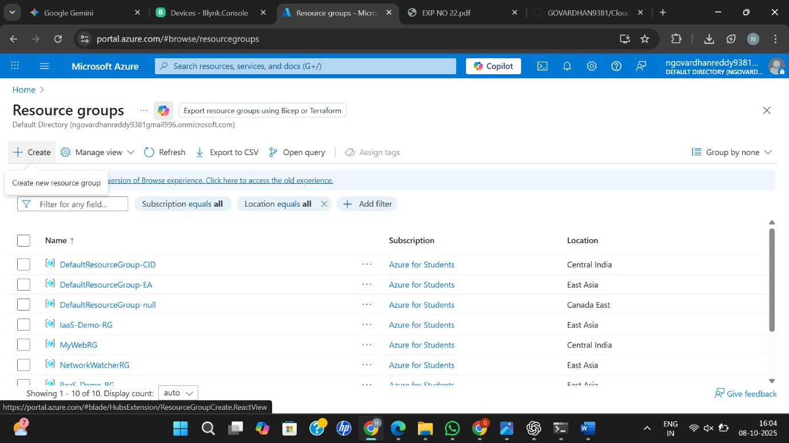

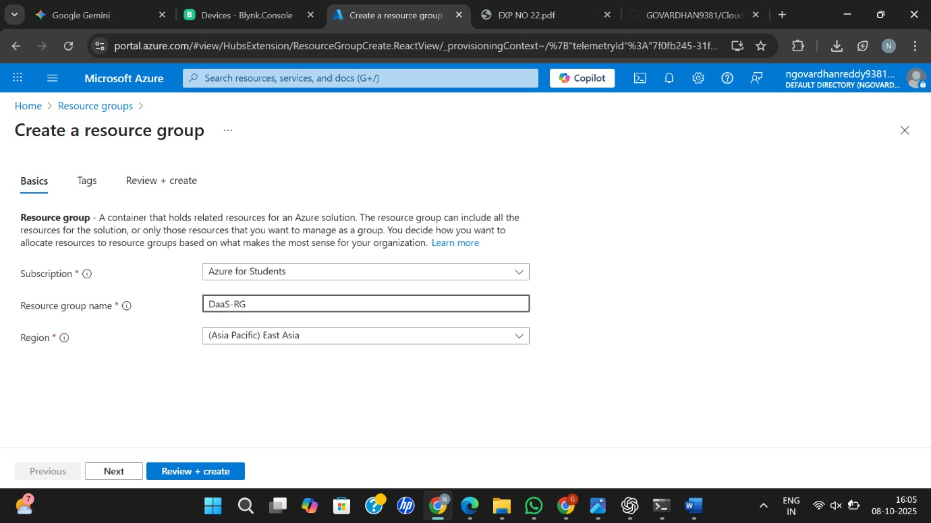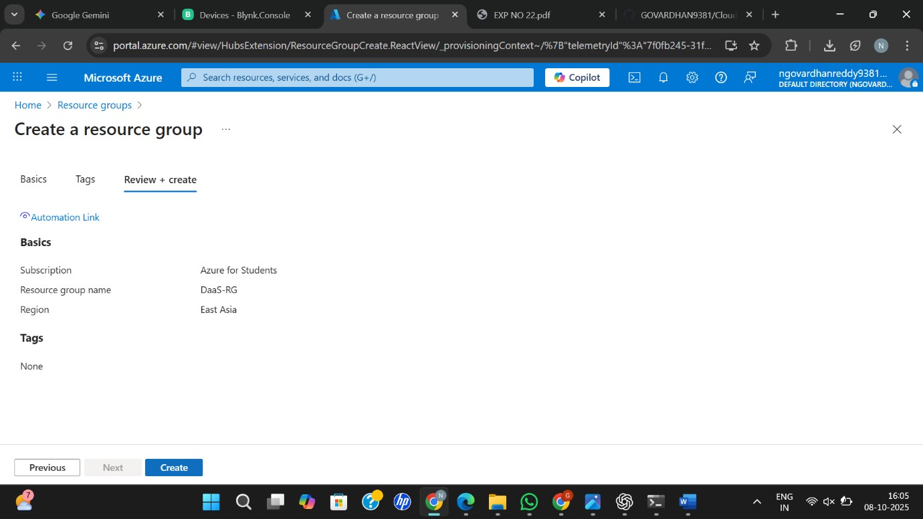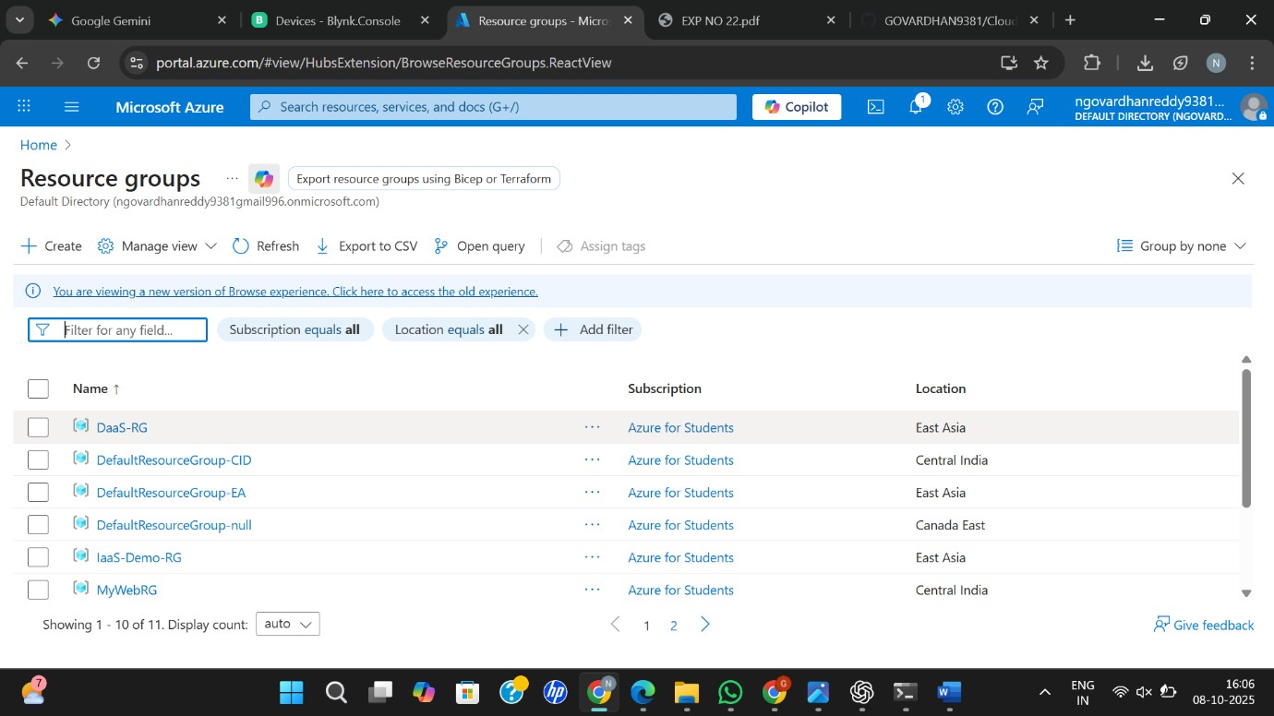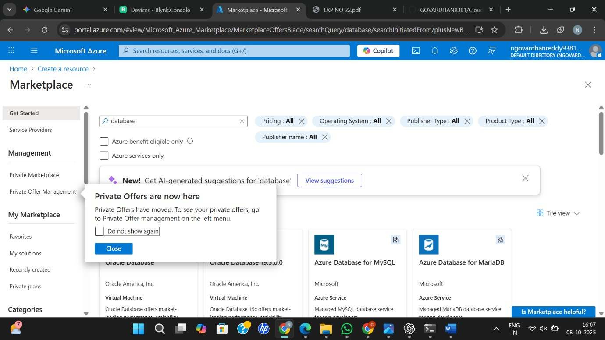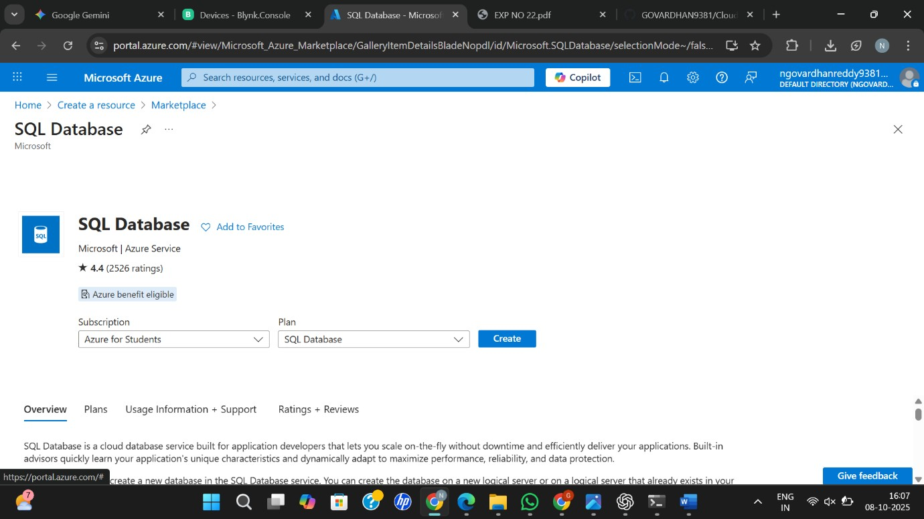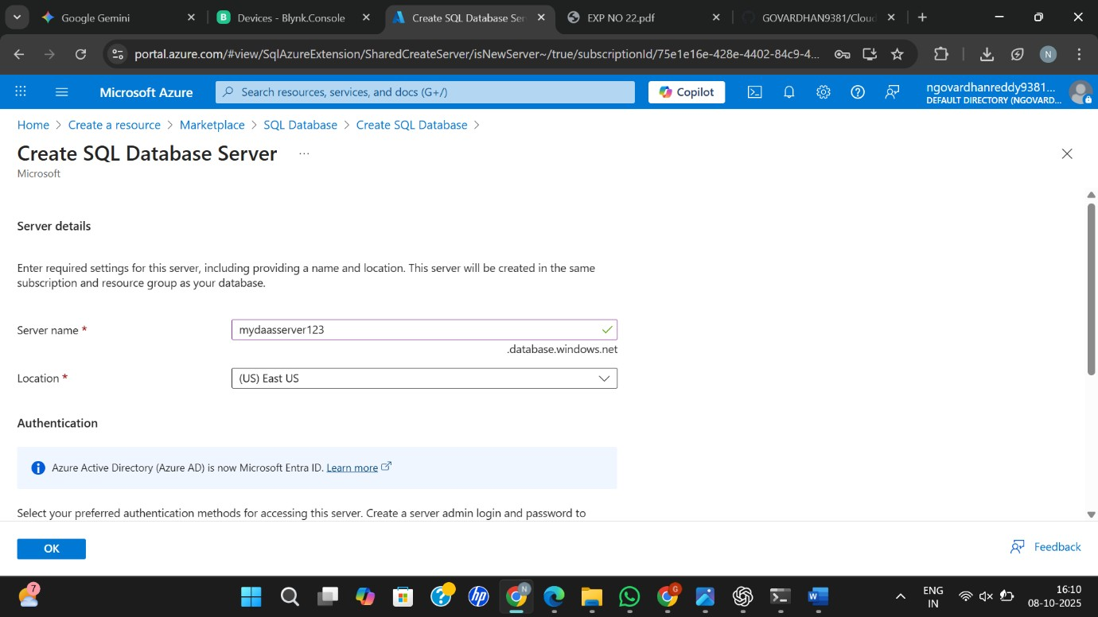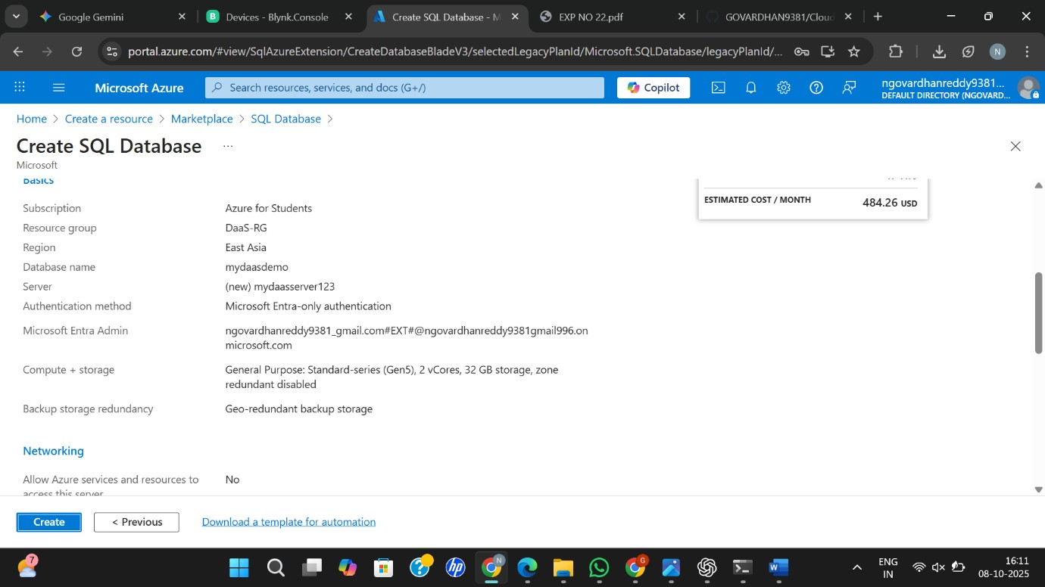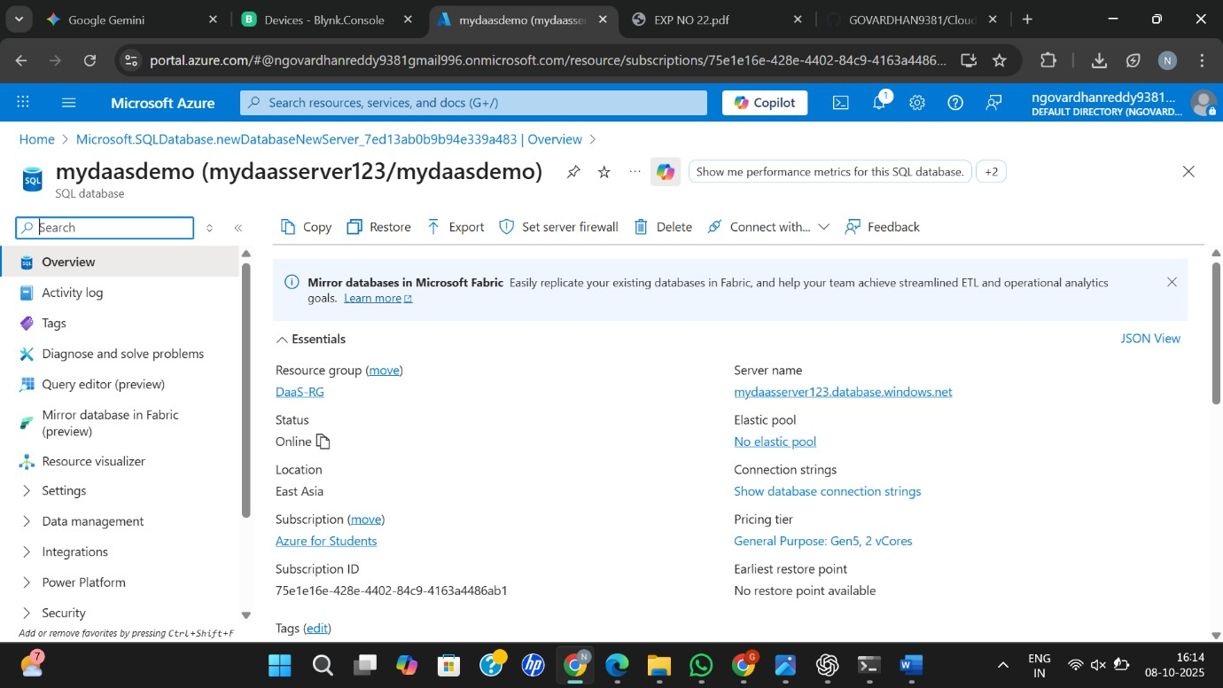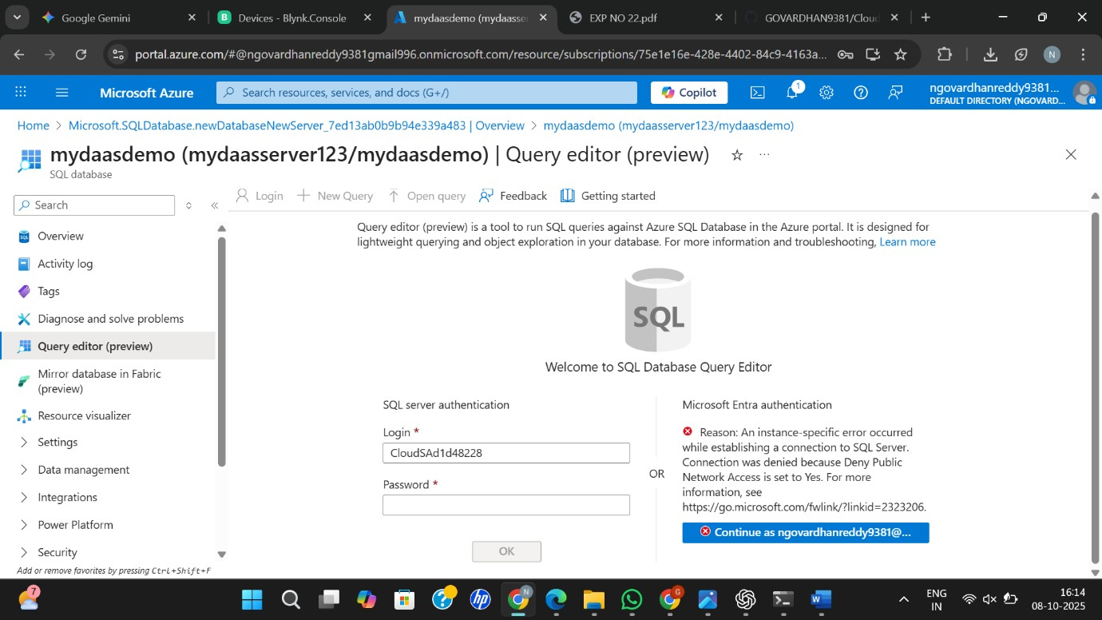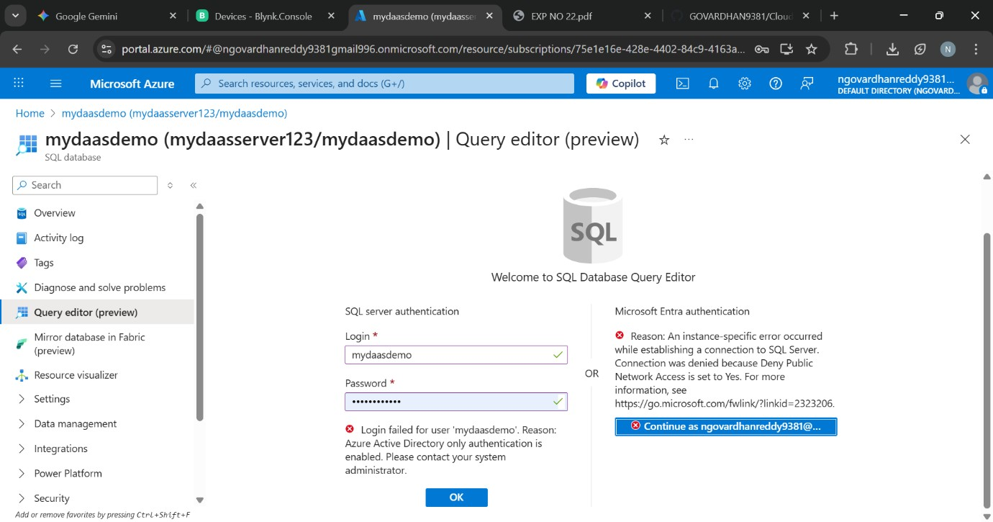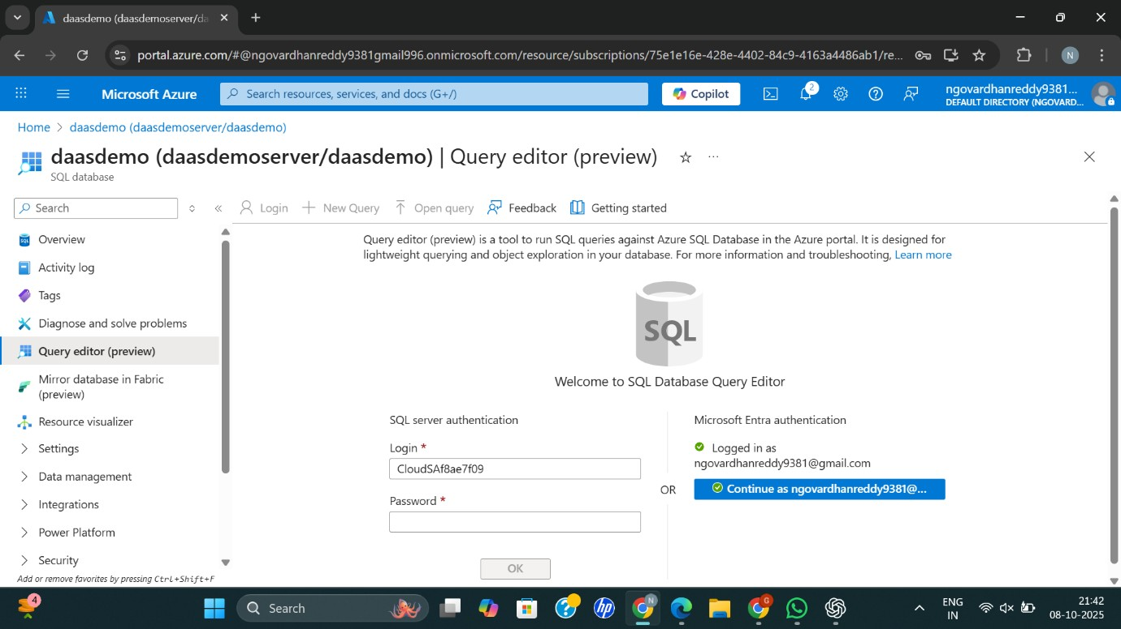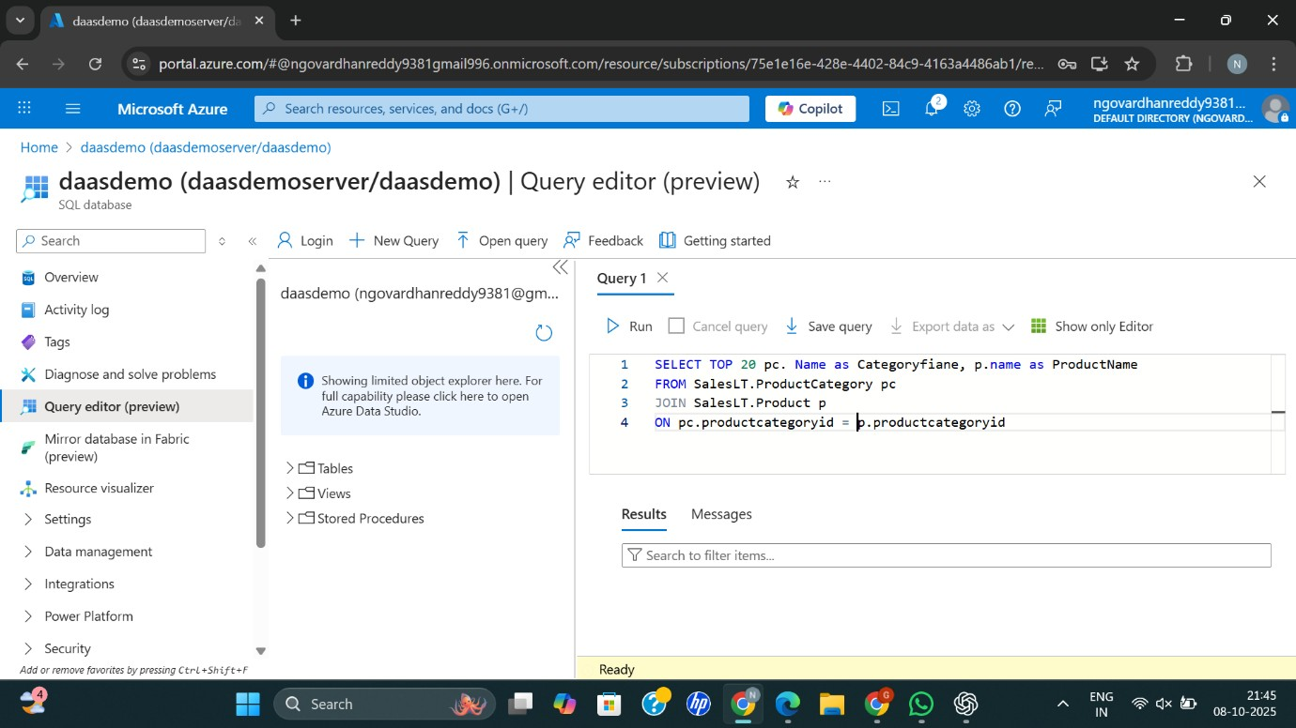

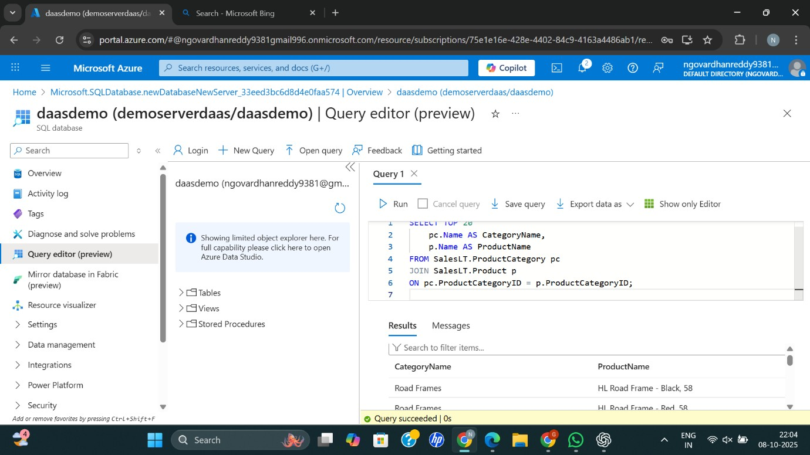

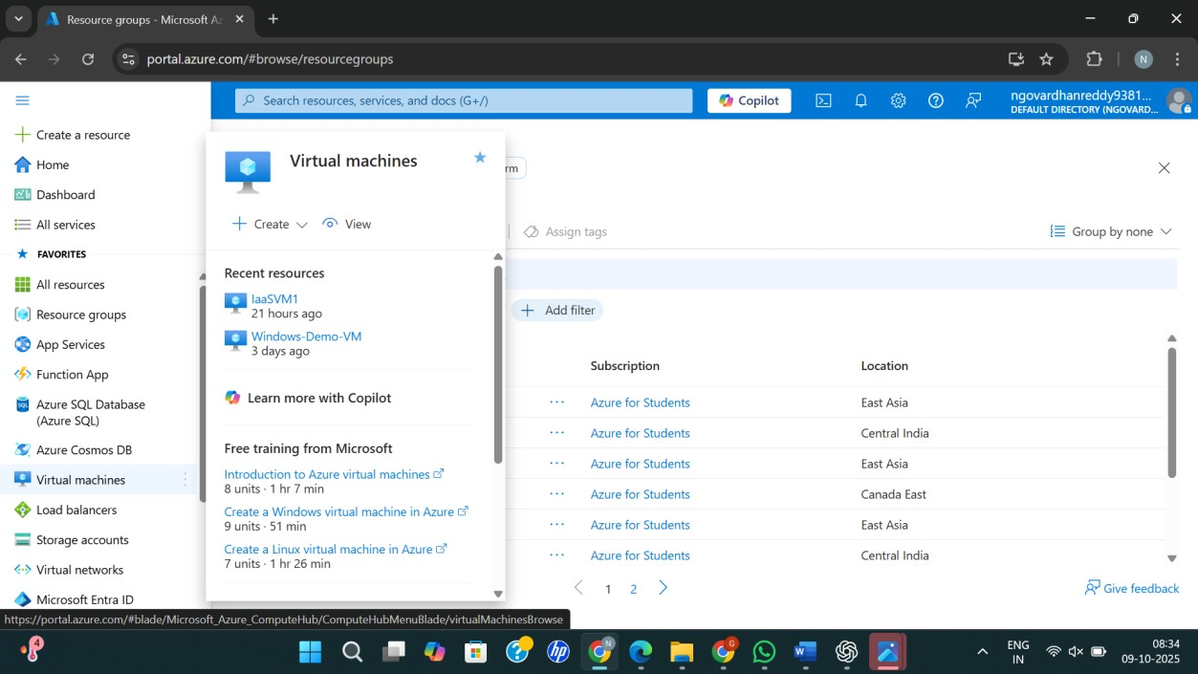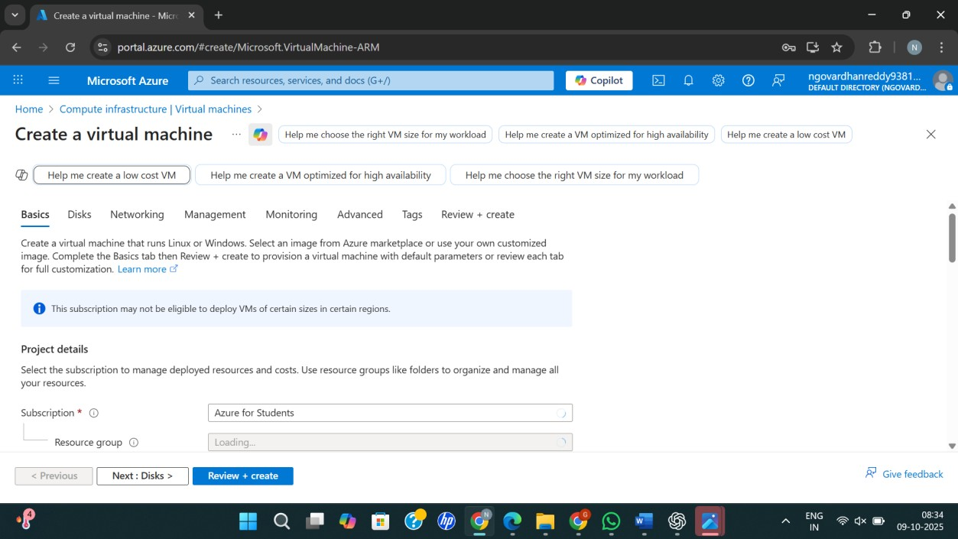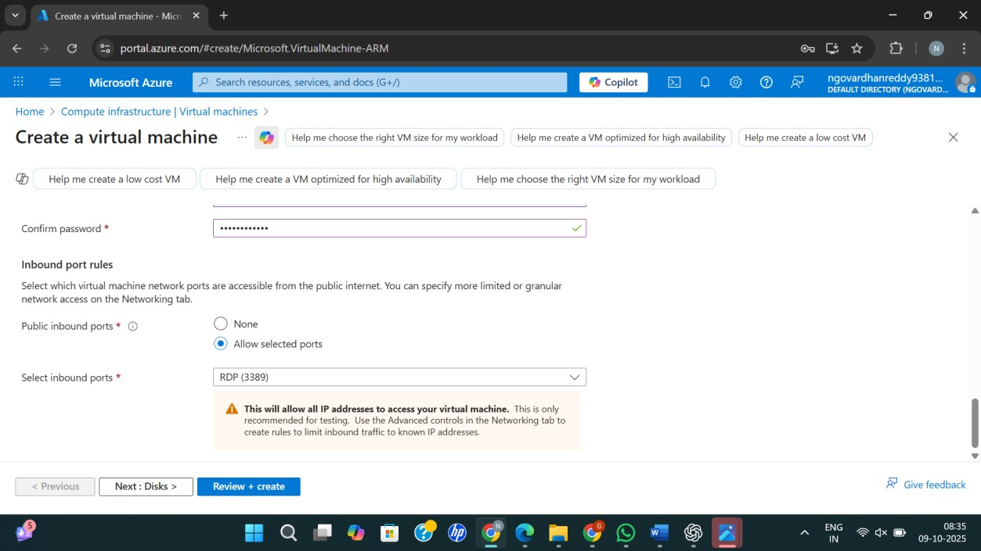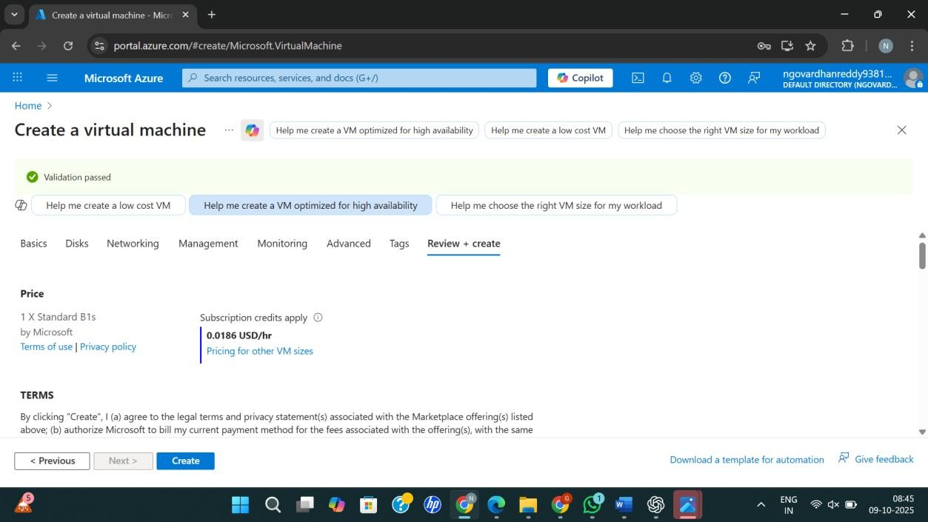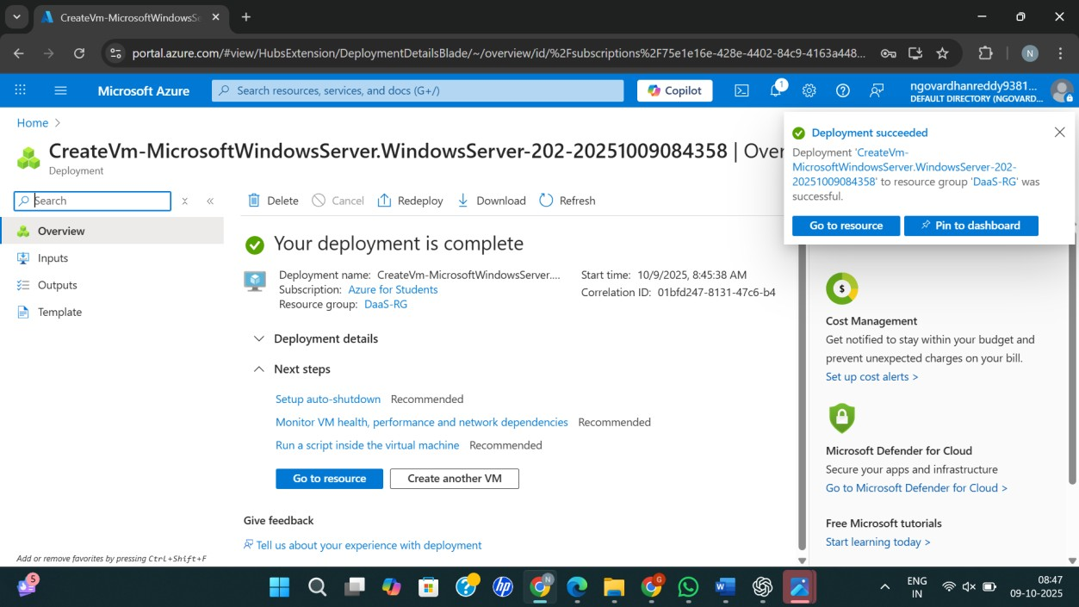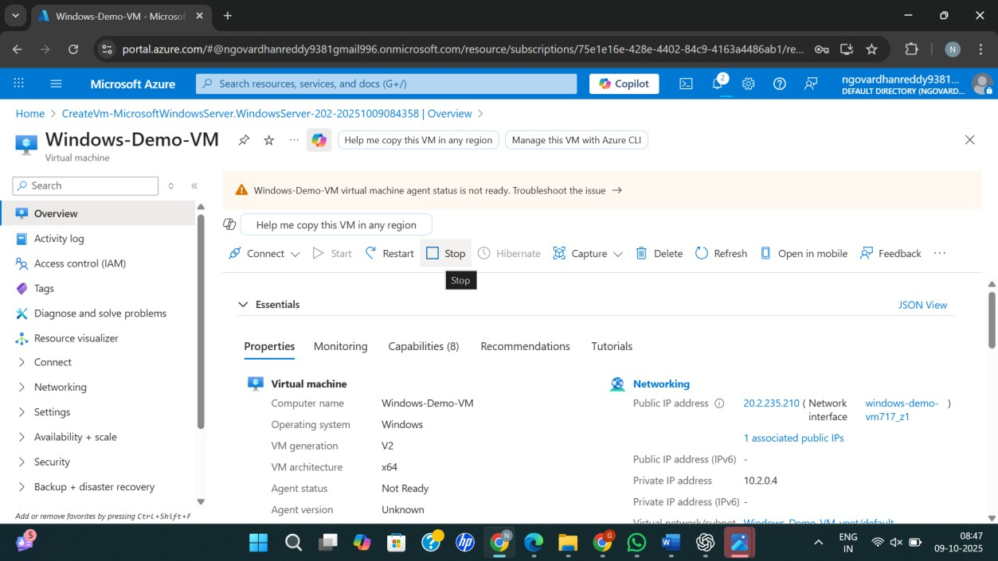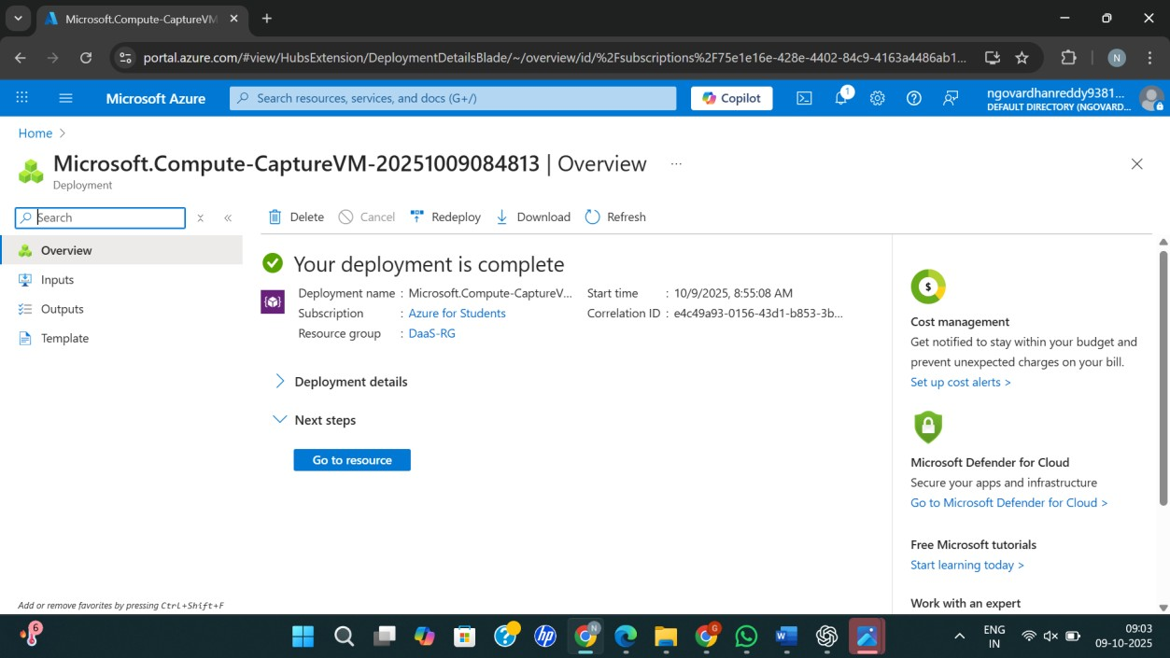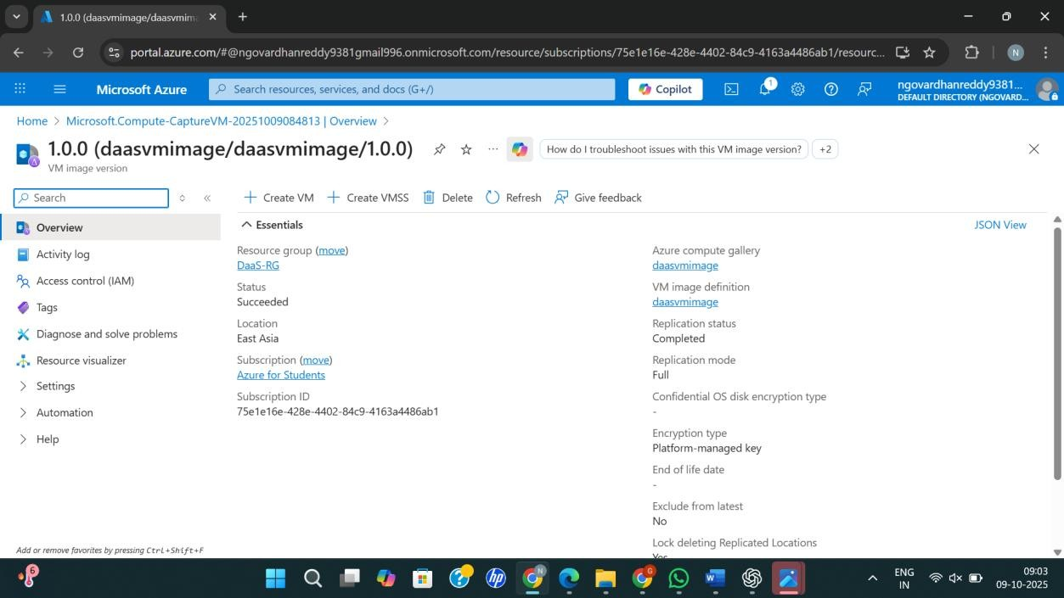

**Result**

Thus, Database as a Service (DaaS) was successfully demonstrated by creating and configuring a managed cloud database using Microsoft Azure.